Scenario 1:

ProcessMonthlyInterest – Apply 1% Interest to All Savings Accounts

CREATE OR REPLACE PROCEDURE ProcessMonthlyInterest IS

BEGIN

    UPDATE accounts

    SET balance = balance + (balance \* 0.01)

    WHERE accounttype = 'SAVINGS';

    COMMIT;

END;

/

EXEC ProcessMonthlyInterest;

SELECT \* FROM accounts;

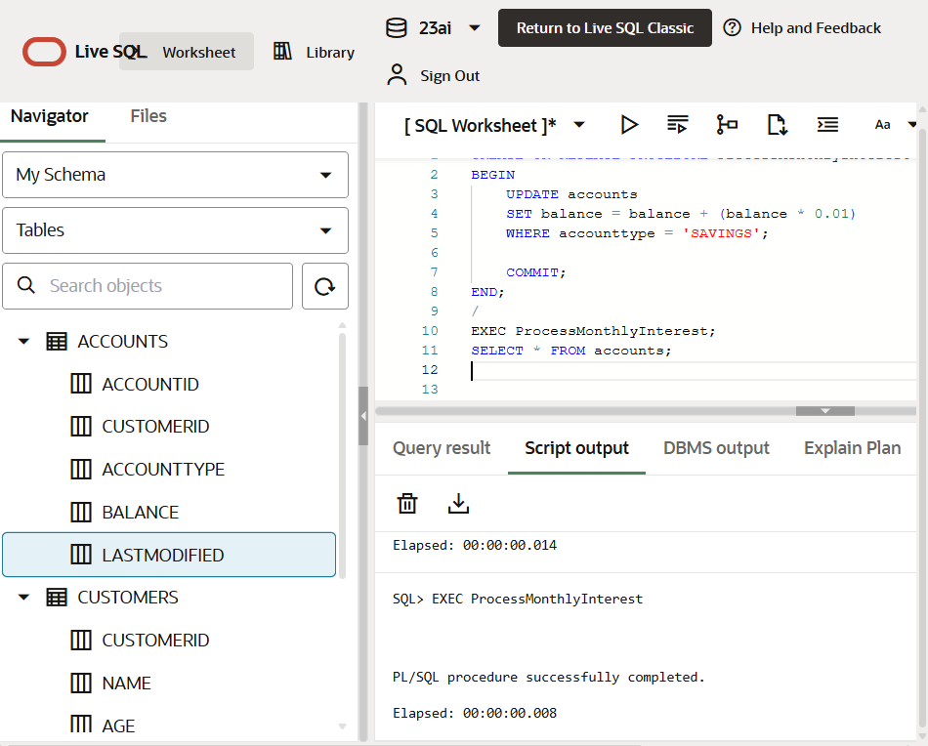

Output

